DETERMINING THE ROLE OF BIG DATA APPLICATIONS IN FRAUD DETECTION AND FINANCIAL SECURITY IN FINANCIAL INSTITUTIONS OF IRELAND

Table of Contents
Introduction 3
Research Background 3
Research aim, objectives, and research question 4
Problem statement 4
Significance of the study 5
Chapter summary 6
Reference 7

Introduction
Fraud detection and financial security are effective parts of reducing fraudulent activities from financial institutions in Ireland. In Ireland, the financial institutions are suffering from cyber threats and fraudulent activities, which need to be addressed for maintaining brand reputation across Ireland. The traditional based fraudulent detection system struggles to identify the complex patterns of fraud. The financial institutions need to implement an advanced analytical approach for identifying complex patterns of the problem activity, which helps to predict the rate from the database.

Research Background
In Ireland, financial institutions suffer from a vulnerable fraud detection system, which creates difficulty in detecting fraudulent activity in their dataset (Njoku et al., 2024). Financial institutions are focusing on implementing advanced fraudulent detection systems with big data analytics into their data protection strategy.
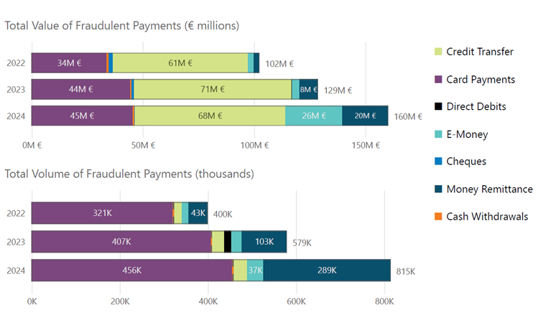
Figure 1: Fraudulent detection in financial institutions
(Source: centralbank.ie, 2025)
The above figure 1, demonstrates that the Central Bank of Ireland experienced a loss of €68 million due to fraudulent detection against credit transfer in 2024. The above figure also highlights that they are experiencing a loss of 456k due to fraudulent activities via card payment. Financial institutions need to focus on implementing Big Data analytics techniques for reducing fraudulent activities within their organisation.

Research aim, objectives, and research question
Aim
The aim of this research is to evaluate the role of Big Data applications in fraud detection and the improvement of financial security frameworks within financial institutions in Ireland.
Objective
- To identify the applications of big data in fraud detection and the improvement of financial security in financial institutions
- To examine the role of Big Data applications in improving regulatory standards and ethical considerations in financial security within financial institutions in Ireland.
- To analyse the current challenge within financial institutions in Ireland for fraud detection and improve security mechanisms.
- To provide recommendations for implementing Big Data applications into fraud detection systems in Irish financial institutions.
Research question
1. What are the applications of big data for fraud detection and the improvement of financial security in financial institutions?
3. What is the role of Big Data applications for strengthening regulatory standards and ethical considerations in the financial security of the financial industry in Ireland?
3. What are the current challenges faced by the financial institutions in Ireland for detecting fraud and improving security mechanisms

Problem statement
In Ireland, the financial institutions are suffering from fraudulent activities, which reduces their brand reputation and customer trust in their bank (Vieras et al., 2025).
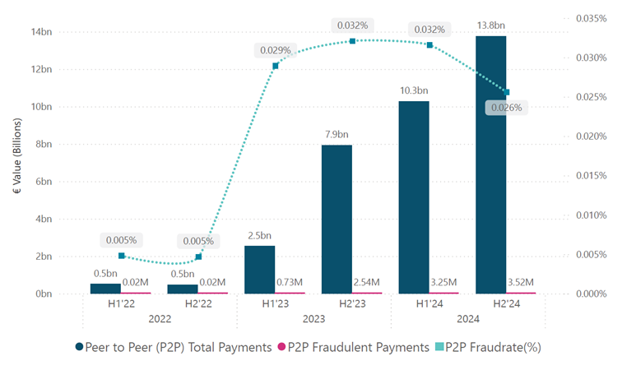
Figure 2: Range of fraudulent activities
(Source: centralbank.ie, 2025)
The above figure 2, highlights that the Central Bank of Ireland is experiencing a higher level of fraudulent activities from 2022 to 2023. This figure highlights the range of increment in the fraudulent activities in their bank, which has increased from 0.005% to 0.029% in 1 year. This evidence highlights that their traditional detection systems are struggling to identify the complete pattern of fraudulent activities (Popoola, 2023). This study investigates the effectiveness of Big data applications and machine learning models that helps financial institutions in enhancing their fraudulent detection system.

Significance of the study
The study provides a discussion about the effectiveness of big data applications for improving the detection system in financial institutions in Ireland. The study evaluates traffic of machine learning and anomaly detection models for reducing fraudulent activities from the financial institution of Ireland. This approach helps to maintain significance of this study from existing literature.

Chapter summary
The discussion demonstrates that financial institutions are required to implement big data applications with machine learning and predictive analytics, which help to detect fraud within the database. This research is conducted to explore how Big Data analytics help to prevent fraudulent activity and improve the regulatory framework in the financial institutions of Ireland.

Reference
centralbank.ie, (2025). Total Value of Fraudulent Payments in Ireland Increased to €160 million in 2024. Available at: https://www.centralbank.ie/docs/default-source/statistics/data-and-analysis/payment-fraud-statistics/payment-fraud-statistics-202485f0d58e-4a6d-4a27-aed4-03717c7bdcd7.pdf?sfvrsn=3a96e1a_1 [Available at: 10.06.2026]
Njoku, D.O., Iwuchukwu, V.C., Jibiri, J.E., Ikwuazom, C.T., Ofoegbu, C.I. and Nwokoma, F.O., 2024. Machine learning approach for a fraud detection system in financial institution: A web base application. Machine Learning, 20(4), pp.01-12.
Popoola, N.T., 2023. Big data-driven financial fraud detection and anomaly detection systems for regulatory compliance and market stability. International Journal of Computer Applications Technology and Research, 12(9), pp.32-46.
Vieras, B., Mark, D., John, A. and Martin, T., 2025. The Impact of Real-Time Financial Fraud Detection on Financial Institutions' Reputation and Customer Trust.

